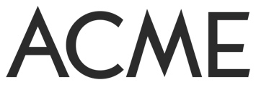
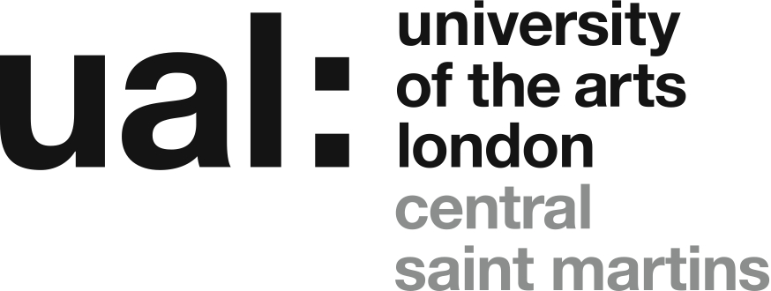

Associate Studio Programme 2021
APPLICATION FORM
Personal Details

Given Name:

Family name:

Address :

Postcode:
Mobile:
Email:

Year of Graduation 2020 2021
Course BA FA CSM BA FA CCW

I confirm that I can legally reside in the UK for the duration of the Programme
Do you consider yourself to be disabled? Yes No

Do you have any access requirements or needs that you would like to tell us about?
(In no more than 100 words)

About Your Work
Please describe your work – its form, concerns and processes – in no more than 200 words. Please include a clear description of the practical aspects of your work (the materials you use, the technical processes this involves, etc.) (max. 200 words)
How would inclusion in the programme benefit your practice?
Please describe how your practice, including the practical aspects of the making of your work, suits the open plan environment of the shared studio at the Highline Building and the accompanying programme of studio visits, and how it will develop in this context. (max. 200 words)

The purpose of the ASP is the support recent graduates establish a professional practice for themselves. It aims in particular to support those graduates whose financial circumstances mean that a subsidised studio space may be the only way they could afford a studio. In relation to this how would you describe your financial circumstances? (max. 100 words).
Please state how you plan to support yourself financially during the Programme. (max. 100 words).

How much time per week do you think you will be able to devote to your work in the studio, and in general terms what do you believe you can achieve through inclusion in the Programme? (max. 100 words)

Declaration by applicant

□ I have read the application notes and confirm that I am eligible to apply. The information I have provided is true to the best of my knowledge.

Signed (name):

Date:

List of Works and Checklist

List of works
 | Title | Date of work | Medium | Dimensions
1
2
3
4
5

Insert URL/Video links (eg. Youtube, Vimeo, etc) here:

Checklist
Yes? | Completed application form
Yes? | 5 images/works, each named and numbered (1-5) (for video see the ‘Further Information’ sheet)
Yes? | CV - max. 2 sides A4

This form, your one-page CV and the accompanying visual material, as JPEGs or PDFs should be gathered in a folder named ‘ASP 2021 Your Name’. This folder must be compressed as a Zip file, not exceeding 4MB in total, and sent as an attachment to:
asp@arts.ac.uk
Your email must have the Subject heading: Associate Studio Programme 2021
Deadline for receipt of application: 10am Monday 25 October.
Please note that for practical reasons any applications, or application materials, received after this deadline, or in any form other than those specified, cannot be considered.

