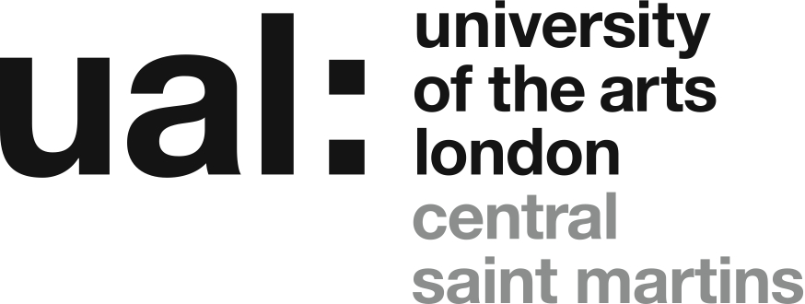

CSM Associate Studio Programme 2017
Highline Building, Elephant and Castle, London, SE17
A collaboration between Acme Studios and Double agents, the Art Programme, Central Saint Martins.
Acme Studios is the UK’s leading provider of affordable studio space and accommodation for professional fine artists. Acme currently provides space for over 600 artists in 12 studio buildings in London. This year will be opening studios in a new building, the Highline Building, a development of student accommodation for University of the Arts London. The Highline Building will include a total of approx. 223 sq.m/2,400sq.ft of studio space. Following the success of the first Associate Studio Programme in Stockwell, which opened in 2013, the building will provide space for a second Associate Studio Programme for twelve graduates of CSM’s BA Fine Art course.
Double agents, the research project based at Central Saint Martins, forged a partnership with Acme Studios in 2010 through an AHRC funded research project focusing on the function, form and future of the Artists’ Studio. That two-year project fed into the activities of both partners and continues as an ongoing long-term collaboration, concerned in particular with the provision of ‘transitional’ studio spaces for recent graduates. The Associate Studio Programmes are one of the collaboration’s key achievements.
The programme at the Highline Building offers:
- Studio space in a new-build ground floor open-plan site totaling approx. 223 sq.m/2,400 sq.ft for twelve graduates from BA Fine Art at CSM.
- Purpose designed studio space located within a UAL Hall of Residence built to a high specification benefiting from natural light, three meter high ceilings, lighting, power, internet access, shared wash-up and WC facilities and 24-hour access.
- Tenancy with Acme Studios for two years, at a rate of £6 per sq.ft (50% standard rental) – we are planning for an average weekly rent for each artist of approximately £25 per week.
- A programme of studio visits by artists, curators and writers.
- Inclusion, for the selected twelve graduates, on Acme’s Waiting List from the start of occupancy – in preparation for the possibility of a future studio tenancy after the completion of the programme.
- Inclusion, for all applicants, on the Associate Studio Programme waiting list, used to fill any places that become free during the two-year period.
The programme is open to applications from current CSM Fine Art students graduating this year and those who graduated in 2016.
This is an experimental programme devised to provide a supportive environment for recent graduates without simply extending the 'comfort zone' of the college experience. The emphasis is on the creation of a mixed but cooperative community of emerging artists, who, at the point of joining the scheme, have already made a commitment to continuing a professional practice. On this basis the scheme will provide a very affordable route into a professional studio space in a mutually supportive environment and underpinned by a programme of collective dialogue and mentoring involving professional artists and academics.
- Schedule:
  - Application deadline 10am Monday 12 June.
  - Applicants will be informed if they have been shortlisted for interview by 5pm Friday 16 June.
  - Interviews will take place on Wednesday 28 or Thursday 29 June.
  - Applicants will be informed of the final decision during the week starting 3 July.
  - The programme runs from on 1 October 2017 until September 30 2019.
Eligibility Criteria
To be eligible for the Central Saint Martins BA Fine Art Recent Graduate Studio Programme 2016 applicants must:
- have graduated from BA Fine Art at Central Saint Martins in 2016, or be in their final year and about to graduate in 2017;
- confirm that you intend to remain in the UK for the duration of the award (October 2017 – September 2019) and are legally able to do that;
- submit a completed application by 10am Monday 12 June.
- if shortlisted, be available to take part in an informal interview at Central Saint Martins, Kings Cross, on Wednesday 28 or Thursday 29 June.
Application Process
Applicants are required to submit their completed application, together with their CV and supporting documentation, as a compressed/Zip folder titled ‘ASP 20017 Your Name’, by email to:
artstudent@csm.arts.ac.uk
Subject heading: Associate Studio Programme 2017
Deadline for receipt of application: 10am Monday 12 June
Applications, or application materials, received after this deadline will not be considered.
Interviews will be held during the week starting Monday 19 June. Applicants shortlisted for interview will be contacted via email by Friday 16 June.
Visual Documentation
You must submit up to 5 images of recent work with your application. Each image must be identified with your name, number (1-5), media, dimensions, date, title. These images (as JPEG or PDF files) must be sent in the compressed/Zip folder containing your CV and Application form and be no larger than 4MB in total.
Video can be submitted but must be uploaded to Vimeo (or an equivalent website) and the direct link provided in the application form, with any required password. A maximum of 3 pieces (or extracts) can be submitted, totaling no more than 15 minutes. If any video work is submitted the combined total number of works submitted, including images, must not exceed 5 (eg. 3 videos and 2 images, 2 videos and 3 images, etc.) Do not send video files by email, these cannot be considered.
Any material received in other formats, on disk or as hard copy, cannot be considered.
Supporting Information
You must also include a CV as a PDF or Word file in your submission folder. Your CV should include details of education and qualifications attained, details of all exhibitions, commissions, awards, publications and employment - two sides A4 maximum.
What happens next
A panel of BA Fine Art staff will review all applications following the deadline and a shortlist will be drawn up. Applicants shortlisted for interview will be contacted via email by Friday 16 June.
- Informal interviews will be held at CSM during the week starting Monday 19 June.
The successful applicants will be selected by taking into account:
- the completed application
- the visual documentation
- the interview
- the suitability of the practice to the open plan studio environment
- the degree of benefit the panel consider that inclusion in the programme will provide
Who is will you meet at the informal interview?
- Alex Schady, Art Programme Director.
- Graham Ellard, Director of the Associate Studio Programme.
- A representative of Acme Studios.

