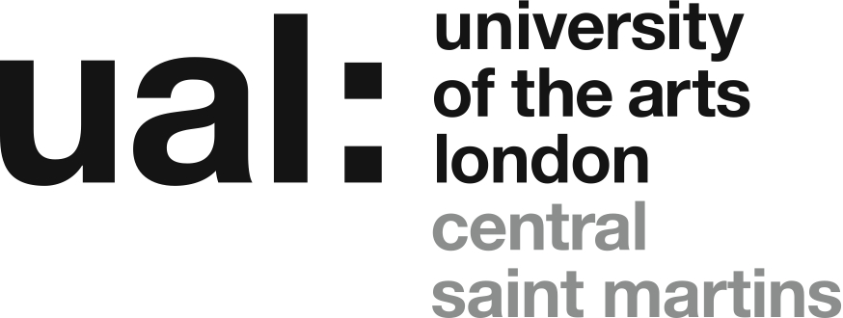

Acme Studios/CSM Associate Studio Programme 2017
APPLICATION FORM
Personal Details

First Name:

Surname:

Address :

Postcode:
Mobile:
Email:

Year of Graduation from BA Fine Art? 2016 2017

I confirm that I can legally reside in the UK for the duration of the Programme
Do you consider yourself to be disabled? Yes No

Do you have any access requirements or needs that you would like to tell us about?
(In no more than 100 words)

About Your Work
Please describe your work – its form, concerns and processes – in no more than 200 words. Please include a clear description of the practical aspects of your work (the materials you use, the technical processes this involves, etc.)

How would inclusion in the programme benefit your practice?
Please describe how your practice, including the practical aspects of the making of your work, suits the open plan environment of the shared studio at the Highline Building and the accompanying programme of studio visits. (max. 200 words).

Please state how you plan to support yourself and how much time you would be able to devote to your work in the studio, and in general terms what you believe you would be able to achieve through inclusion in the Programme. (max. 200 words).

Declaration by applicant

□ I have read the application notes and confirm that I am eligible to apply. The information I have provided is true to the best of my knowledge.

Signed (name):

Date:

List of Works and Checklist

List of works
 | Title | Date of work | Medium | Dimensions
1
2
3
4
5
Insert URL/Video links (eg. Youtube, Vimeo, etc) here:

Checklist
Yes? | Completed application form
Yes? | 5 images/works, each named and numbered (1-5) (for video see the ‘Further Information’ sheet)
Yes? | CV - max. 2 sides A4

This form, your one page CV and the accompany visual material (JPEGs or PDFs in a compressed/Zip folder named ‘ASP 2017 Your Name’, not exceeding 4MB in total, as an attachment) must be sent to:
artstudent@csm.arts.ac.uk
Subject heading: Acme Studios/CSM Associate Studio Programme 2017
Deadline for receipt of application: 10am Monday 12 June.
Please note that for practical reasons any applications, or application materials, received after this deadline, or in any form other than those specified, cannot be considered.

