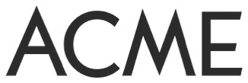
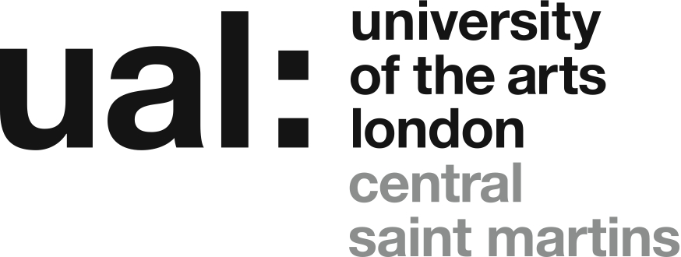

Highline building, 10 Steedman St, London SE17 3AF
The Associate Studio Programme was developed in 2013 as a collaboration between Acme Studios and Double agents, the Art Programme, Central Saint Martins.
Double agents, the research project based in the Art Programme at Central Saint Martins, developed a partnership with Acme Studios in 2010 which led to an AHRC funded research project focusing on the function, form and future of the Artists’ Studio. The two-year project fed into the activities of both partners – a concrete outcome was the provision of ‘transitional’ studio spaces for recent graduates and for CSM this has been central to its continuing research into the role, definition and form of the studio both in college and after graduation.
Acme is the UK’s leading provider of affordable studio space and accommodation for professional fine artists. Acme provides space for over 650 artists in 12 studio buildings in London. In 2013 together we created the Associate Studio Programme in the Glassyard building in Stockwell. In 2015 a second ASP studio was created in the Highline Building, a development of student accommodation for UAL. The Highline Building includes a total of approx. 223 sq.m/2,400sq.ft of studio space and provides space for fifteen recent graduates of BA Fine Art at CSM and CCW.
The Associate Studio Programme offers:
- Studio space in a new-build ground floor open-plan site totaling approx. 223 sq.m/2,400 sq.ft. Built to a high specification the spaces benefit from natural light, three meter high ceilings, lighting, power, heating, wi-fi, wash-up and WC facilities and 24-hour access.
- Tenancy with Acme Studios for just under two years (22 months) at a monthly rent for each artist of approximately £112 p/month.
- Studio visits from artists and curators – twelve visits selected and managed by Associates.
- Peer to peer studio visits from ex-Associates studying on MA courses (inc. Goldsmiths, RCA, The Slade, Royal Academy).
- Support (funding and promotion) of public Open Studio exhibitions/events.
- Advisory sessions with ASP Director Prof. Graham Ellard.
- Inclusion, for the selected fifteen graduates, on Acme’s Waiting List from the start of occupancy – in preparation for the possibility of a future studio tenancy after the completion of the programme.
- Inclusion, for all applicants, on the Associate Studio Programme waiting list, used to fill any places that become free during the two-year period.
The programme is open to applications from CSM and CCW BA Fine Art students who graduated in 2022 and 2023.
This is an experimental programme devised to provide a supportive environment for recent graduates without simply extending the 'comfort zone' of the college experience. The emphasis is on the creation of a mixed and cooperative community of emerging artists, who, at the point of joining the scheme, have already made a commitment to continuing a professional practice. On this basis the scheme will provide a very affordable route into a professional studio space in an open plan, mutually supportive environment underpinned by a programme of collective dialogue and mentoring involving professional artists and academics.
- Schedule:
  - Application deadline 10am Friday 29 September.
  - Applicants will be informed if they have been shortlisted for interview by 5pm Friday 6 October.
  - Interviews will take place on 16 and 17 October.
  - Applicants will be informed of the final decision by Monday 23 October.
  - New Associates move into the studio on 18 December 2023. The Programme runs until 30 September 2025.
Eligibility Criteria
To be eligible for the Associate Studio Programme 2023 applicants must:
- have graduated from BA Fine Art at CSM or CCW in 2022 or 2023;
- confirm that you intend to remain in the UK for the duration of the award (December 2023 – September 30 2025) and are legally able to do that;
- submit a completed application by 10am Friday 29 September.
- be available for an on-line interview on the 16 and 17 October.
Application Process
Applicants are required to submit their completed application, together with their CV and supporting documentation, as a compressed/Zip folder titled ‘ASP 10 2023 Your Name’, by email to:
asp@arts.ac.uk
Subject heading: ASP 10 2023
Deadline for receipt of application: 10am Friday 29 September.
Applications, or application materials, received after this deadline, or in a form other than described below, will not be considered.
Further information about file formats etc. is included below.
Visual Documentation
You must submit up to 5 images of recent work with your application. Each image must be identified with your name, number (1-5), media, dimensions, date, title. These images (as JPEG or PDF files) must be sent in the compressed/Zip folder containing your CV and Application form and be no larger than 4MB in total. This is vital, if you try to submit a larger file it may be rejected by the UAL email system.
Video can be submitted but must be uploaded to Vimeo (or an equivalent website) and the direct link provided in the application form, with any required password. A maximum of 3 video pieces (or extracts) can be submitted, totaling no more than 15 minutes. If any video work is submitted, the combined total number of works submitted, including images, must not exceed 5 (eg. 3 videos and 2 images, or 2 videos and 3 images, etc.) Do not send video files by email, these cannot be considered.
Any material received in other formats, or not conforming to the requirements above (including the file size limit of 4MB), cannot be considered.
Supporting Information
You must include a CV as a PDF or Word file in your submission folder. Your CV should include details of post-school education and qualifications attained, and details of exhibitions, commissions, awards, publications and employment - two sides A4 maximum.
What happens next
A panel of CSM and CCW BA Fine Art staff – Graham Ellard, Alex Schady (Programme Director, Art, CSM), Kimathi Donkor (Course Leader BA Painting, Camberwell) and Elizabeth Peebles (Year Three Leader BA Fine Art, Chelsea) - will review all applications following the deadline and a shortlist will be drawn up. Applicants shortlisted for interview will be contacted via email by 5pm Friday 6 October.
- On-line interviews will be held on 16 and 17 October.
- Decisions will go out by Monday 23 October.
- The new group of 15 Associates will move in on 18 December 2023 (until September 30, 2025)
The successful applicants will be selected by considering:
- the completed application and your responses to the questions
- your work as presented in the visual documentation
- the suitability of your practice and approach to the shared, open plan, co-operative studio environment
- the degree of benefit that the panel consider inclusion in the programme will provide.

